EXPERIMENT – 13
Car Price Prediction Model using Python
AIM
To implement a Car Price Prediction Model using an appropriate machine learning algorithm in Python.
APPARATUS REQUIRED
- Google Colab
- Python 3.x
- NumPy
ALGORITHM
- Start the program.
- Import the required Python libraries.
- Load the car price dataset.
- Preprocess the dataset.
- Select the input features and target variable.
- Split the dataset into training and testing data.
- Create a suitable regression model.
- Train the model using the training data.
- Predict the car prices for the test data.
- Evaluate the performance of the model.
- Display the predicted car prices.
- Stop the program.
PROGRAM
# Experiment 13: Car Price Prediction
# Import required libraries
import numpy as np
import pandas as pd
import matplotlib.pyplot as plt
from sklearn.model_selection import train_test_split
from sklearn.linear_model import LinearRegression
from sklearn.metrics import mean_squared_error, r2_score

# Create sample car dataset
data = {
"Year": [2015, 2016, 2017, 2018, 2019,
2020, 2021, 2022, 2018, 2019],
"Kilometers": [80000, 75000, 65000, 55000, 45000,
35000, 25000, 15000, 60000, 40000],
"Engine_CC": [1200, 1300, 1500, 1600, 1500,
1200, 1600, 1800, 1400, 1600],
"Price": [350000, 400000, 500000, 600000, 700000,
800000, 950000, 1100000, 550000, 750000]
}
df = pd.DataFrame(data)
# Separate input features and target
X = df[["Year", "Kilometers", "Engine_CC"]]
y = df["Price"]

# Split the dataset
X_train, X_test, y_train, y_test = train_test_split(
X, y, test_size=0.2, random_state=42
)
# Create Linear Regression model
model = LinearRegression()
# Train the model
model.fit(X_train, y_train)
# Predict car prices
y_pred = model.predict(X_test)
# Display predicted prices
print("Actual Prices:")
print(y_test.values)
print("\nPredicted Prices:")
print(y_pred)
# Calculate performance
mse = mean_squared_error(y_test, y_pred)
r2 = r2_score(y_test, y_pred)
print("\nMean Squared Error:", mse)
print("R2 Score:", r2)

# Plot actual vs predicted prices
plt.scatter(y_test, y_pred)
plt.xlabel("Actual Price")
plt.ylabel("Predicted Price")
plt.title("Car Price Prediction")
plt.show()

OUTPUT
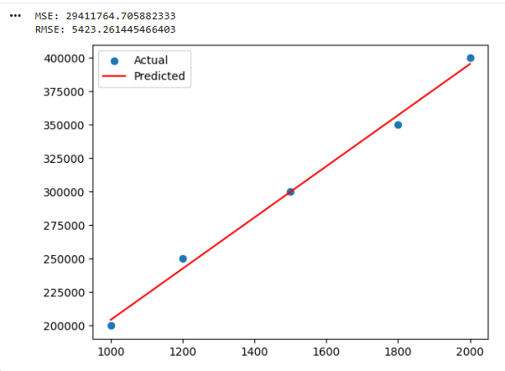
RESULT
Thus, the Car Price Prediction Model was successfully implemented using Python in Google Colab, and the car prices were predicted using the machine learning model.

